19.45: We will need to use Equations (19.3),

- The work done by the system during the process: Along ab or cd, W=0. Along bc,

- The heat flow into the system during the process: 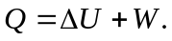

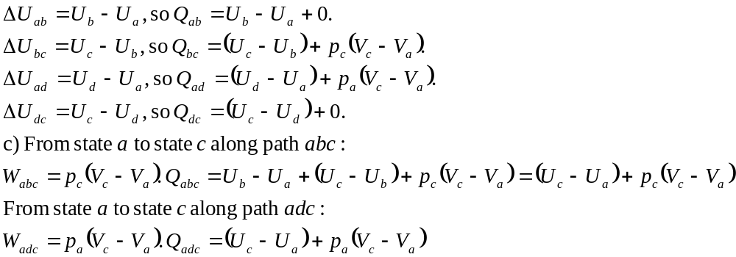Assuming 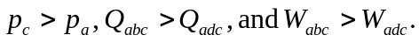
d) To understand this difference, start from the relationship 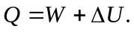 The internal energy change 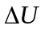 is path independent and so it is the same for path abc and path adc. The work done by the system is the area under the path in the pV-plane and is not the same for the two paths. Indeed, it is larger for path abc. Since is the same and W is different, Q must be different for the two paths. The heat flow Q is path dependent.

